**Engineering method**

**Context of the problem**

A person wants to open a video game store in Cali, Colombia. The client before entering in the store has to check the digital catalogs, when this interaction with the virtual catalog has finished, the client adds the games of interest to their list. Once the list is finished, it generates a code that the client has to take into account when entering into the store, (to clarify, each available game has an attached code that identifies itself). The customer must go through several sections sequentially in order to complete the purchase:

Section 1: Upload list to tablet.

Section 2: Make queries to find blocks or shelves where the video games on the list are located.

Section 3: Pick up physical video games in the order provided in section 2.

Section 4: Paying for video games.

The intention is to allow Caleños to know a little about how the new store will work in the city. The video game purchase process must be simulated from the end of section 1.

**Identification of the problem**

**Identification of needs and symptoms**

* Potential store customers want to see how the buying process will work.
* There is no program that simulates the purchase process.
* The simulation must be as close as possible to the reality of the process.

**Definition of the problem**

A software program is required, which simulates the entire sequential purchase process in the video game store

**Information gathering**

In order to be as faithful as possible to the actual purchase process, the following detailed purchase sequences are simulated:

Sequence 2: This is a place provided with a set of stations where the provided tablet can be connected. These stations allow very quick inquiries. The list enters the names of the video games to the station and this indicates the blocks or shelves where you should look for the game of your interest. To speed up the collection process of the copies, the team orders the list of games according to the location of the shelves in such a way that the client follows the best route (if the game is sold out, its code will not appear on the final sorted list). At this stage the client can use 2 different sorting algorithms to accomplish this task.

Sequence 3: Here the physical copies of the videogames on the list will be collected in the order provided in the previous stage. To make this task easier for each client, an automated basket is assigned, it follows them to locate the games that they find, one on top of the other, following the order provided in the previous stage.

Sequence 4: Taking into account the time in which the client has entered the store, plus the time that has passed collecting the games from each shelf, the order for going to the cashiers starts to be established. In this case, the strategy is as follows: everyone makes a single queue even if there are several cashiers or service spots. When one or more service spots are available, as many clients as there are available spots passed, to be attended one by one in each of them. Since customers come from one only line, it can be said that all are served in the same order of arrival. The order of departure may vary, as it will depend on the time it takes for each person to be attended to in the service spot (number of items to be purchased). It should be noted that since the games come in a basket, the last game added will be the first one checked and packed.

**Search for creative solutions**

This process was made through group brainstorming, associating the idea of a simulation to technological tools that are used nowadays, taking into account the user experience and the capabilities of software to process data.

**Alternative 1**

Taking into account that the objective is to create a simulation of the approximate operation that the new video game store would have, this approximate customer simulation is presented:

The client chooses the video games they want from their list and the page provides them with a QR code and a link to send a message through the Telegram instant messaging platform. By sending this QR code, the video game store bot will register its entry, the bot continues to send a link with a 3D simulation of the store that allows integrated navigation through different areas.

Along with this and with the help of the bot's designed operations, it will provide a file containing the shelves where you can find the games you want. In addition, the 3D application will have an alert button to notify you when you have finished choosing your video games, at this point the bot verifies and assigns a position in the payment row.

According to the data from the previous stage, the 3D application calculates the time that the queue will take and then the bot through Telegram will simulate the billing of the video games until the purchase is finished.

**Alternative 2.**

In order to make a very real simulation of the shopping experience in the new video game store, a 2D minigame adapted for mobile devices is designed, a game in which the creation of an avatar for the customer is allowed at the time to register.

Once fully registered, the game displays the catalog of video games available for purchase from the web page, with this a barcode is generated for the customer that is saved in the avatar objects. The video game now displays the option to go to the store, and by clicking it it simulates a car journey that lasts no more than 3 seconds, when arriving at the store the customer can interact with the store by delivering the generated barcode from their objects and in return you are given your list. From this moment the avatar enters a version of the store designed as a video game with the possibility of moving to the shelves where the video games are and with an arrow it indicates the order according to its ordered list.

Once all the video games have been registered in the virtual basket of the client, it indicates the way to the payment area. According to their order of arrival, the game will simulate the waiting time and then the duration of the billing until you can finish your purchase, where the game ends with a ticket of the information collected.

**Alternative 3**.

By analyzing the sequences we identify several processes that can be represented through data structures that closely match the conditions of the store. A simulation assisted by a desktop application that makes use of the different data entered by the user in order to simulate the whole situation. In this desktop application, at the beginning you enter the number of cases you want to simulate, the number of available cashiers, the catalog, customer identifications and game lists.

After that, a graphical interface roughly simulates the situation presented, and at the end it returns the order of exit of the customers entered, the value of each purchase and the order in which the games were left.

**Transition of ideas to Preliminary Designs**

Now we discard the ideas that are not feasible, so we discard alternative 1, because it involves a greater complexity than considered, since it is a simulation that gives an idea to the clients of the operation of the store, to which a 3D simulation would involve making an exact or approximate description of the operation and the facilities, which is far from the objective and increases the complexity of implementing the solution considerably.

A careful review of the remaining alternatives leads us to the following conclusions:

Alternative 2 - 2D simulation

* The game simulates the operation of the store from a third-person perspective.
* The game requires complex graphical implementations for the representation of the different structures that are used in the purchase of video games.

Alternative 3 - Desktop simulation

Shows the operation of the store in a basic way.

Process the simulated enviroment through numerical values. The processes are represented in the first person.

**Evaluation and selection of the best solution**

To evaluate the alternatives we propose different criteria to evaluate and select the best alternative:

Criterion 1. Scope of the objectives

[1]: The simulation does not represent the operation of the store.

[2]: The simulation shows the operation of the store in a simple way.

[3]: The simulation shows the operation of the store in detail.

Criterion 2. Ease of implementation

[1]: The simulation is complex to implement.

[2]: The simulation has a medium complexity to implement.

[3]: The simulation is easy to implement.

Criterion 3. Fidelity to the actual process

[1]: The simulation does not show the described processes.

[2]: The simulation shows some of the processes described.

[3]: The simulation shows all the processes described.

|  |  |  |  |  |
| --- | --- | --- | --- | --- |
|  | Criterion 1 | Criterion 2 | Criterion 3 | Total |
| Alternative 2 | 3 | 2 | 3 | 8 |
| Alternative 3 | 3 | 3 | 3 | 9 |

According to the criteria that we propose, we select alternative two, since it obtained the highest score.

**Preparation of reports and specifications**

Specification of the problem (In terms of input / output)

**Problem:** Desktop simulation for the video game store

**Inputs:** number of cashiers available during the day, number of shelves, identifier for each shelf, number of games that each shelf contains, game identifier,game price, number of copies of each game, number of customers that will enter the store, identification of each customer and the codes of the games that each customer will buy

**Outputs:** the customer's ID must be shown followed by the total value of their purchase and the series of identification codes of their purchased games, following the order in which they were packed.

**Considerations:**

1. When the customer enters the store, their list of games must be ordered in such a way that the buyer follows the best route on the shelves (If the game is sold out, it will not appear in the final list).
2. When customers go to pay they will make a single line and will pass whenever there is an available cashier.
3. Clients will be served on a first-come, first-served basis.
4. At checkout, the last game added by the customer will be the first to be billed and packed.
5. Each customer takes 1 unit of time to pick up a game.
6. If two users take the same time, the one who arrived first at the store will leave first.

**Design implementation**

1. Sort the buyer's game list so that it follows the best route.
2. Pack the games so that the last game added by the customer is the first.
3. Calculate the order in which customers should be served.

**Especificación de subrutinas:**

|  |  |
| --- | --- |
| Name: | searchPhysicGames |
| Description: | Sort the buyer's game listing to follow the best route. |
| Inputs: | - c: Client , is the client to whom the list of games must be ordered |
| Outputs: | Client, the customer with his ordered list |

**Construction:**

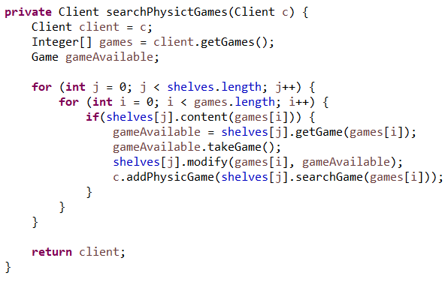

|  |  |
| --- | --- |
| Nombre: | payGames |
| Descripción: | Pack the games so that the last game added by the customer is the first. |
| Entrada: | - c: Client , the customer with the games they want to buy |
| Retorno: | Client, the customer with their packed games |

**Construction:**

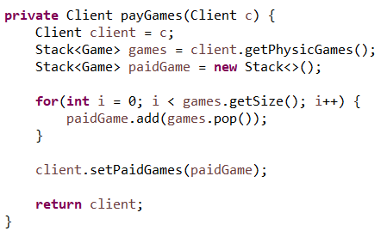

|  |  |
| --- | --- |
| Nombre: | payGames |
| Descripción: | Establish the order in which customers must proceed to pay |
| Entrada: | - c: Client ,Customers who are in the establishment |
| Retorno: | Client, the order in which customers should leave |

**Construction:**

